V. VALIDATION THROUGH SIMULATION
Shortened replacement for Section V of SensoSpoo_IEEE_Report_Rev C. Tables and figures keep their existing numbers, except that the last table is renumbered VI to close a gap in the original (it was numbered VII with no Table VI anywhere in the report).

A. Scope of the Evidence
The evidence here is of two kinds, kept apart because they support different claims. Algorithmic simulation evidence is a controlled comparison of controller variants over a fixed scenario set in a simulated plant driven by synthetic tremor; it establishes whether the architecture works, and it is what the delivered controller was designed and tuned against. Public real-data evidence is analysis of recordings released by other researchers, used both to test the sEMG assumptions the fusion rests on and to replace the synthetic tremor input with a recorded one.
There is no hardware tier: no prototype was built, no bench measurement taken and no human subject recorded, so every actuator, coil and flexure parameter is a data-sheet value applied to a structure that was never manufactured. The claim this work is entitled to make is therefore bounded — the algorithm was validated in simulation, and public real data was used to test both the sEMG assumptions and the tremor input. Physical closed-loop human validation was outside the scope of this project.

B. Simulation Environment and its Verification
The plant integrates mechanism kinematics, actuator electrical dynamics, payload inertia and sensor noise at a 0.5 ms mechanical step, with an 800 Hz outer attitude loop and a 10 kHz inner current loop nested inside it. Three things support treating it as a usable development baseline. The mechanism is verified analytically — rod-closure error 3.5×10⁻¹⁸ m, Jacobian error 4.5×10⁻¹², energy-balance residual 3.7×10⁻¹² W — so the kinematic and power bookkeeping are exact to numerical precision; this verifies the implementation, not the parameter values. The fast fixed-step solver used for the sweeps agrees with a continuous-time Simulink reference on a nominal case to within a small residual in joint angle and suppression. And seventeen automated validation groups, covering geometry, physics, hardware limits, the controller, the estimator and the sensor front ends, run in roughly 80 s and must pass before any result is generated.
What the model omits matters equally: no hysteresis, creep or backlash in the flexure, and no friction beyond a simple guide term. It is an algorithm-development baseline, not a validated digital twin, and absolute performance figures inherit that limitation.

C. Test Protocol and Metric Definitions
The benchmark comprises twenty scenarios spanning four questions: a tremor-frequency sweep at 4, 5, 7, 8, 9, 11 and 12 Hz; waveform and amplitude (mixed multi-frequency, chirp, irregular, and a 3° case); voluntary motion alone and superimposed on tremor; and plant robustness (no payload, 15 g payload, a 5.8 V bus in place of 7.4 V, and a degraded actuator with +20 % coil resistance, −15 % force constant and doubled guide friction).
Tremor suppression is the percentage reduction in attitude RMS against a baseline in which the spoon is rigidly attached to the hand under identical input, scored from t = 1.5 s to exclude the start-up transient and retained as negative rather than clipped when a controller does worse than no control, since that is diagnostic. Attitude error RMS is reported alongside and is the only meaningful metric on the voluntary-motion-only scenario, where suppression is undefined. Every variant runs over identical scenarios with identical sensor seeds, so the comparison is a controlled experiment rather than a set of separately tuned runs.
Three scenarios demand more than the actuator can supply, judged by an inverse-dynamics bound assuming perfect knowledge and exact tracking: cases 5 (10 Hz, 3°) and 14 (8 Hz, 5°) need 7.10 V and 7.50 V of a 7.4 V bus, and case 20 (20 Hz, 1°) needs 1.84 A against a 1.5 A limit and 5.28 W against a 4.4 W continuous rating. No controller could have succeeded on these, so they are excluded from the headline mean — with all three averages reported together so the exclusion is visible rather than silent.

D. Controller Comparison on Synthetic Tremor
Table IV gives the six-variant comparison. Variants differ only in the estimator and in whether sEMG is used; plant, scenarios and seeds are identical throughout.
Variant | All scored (%) | Feasible (%) | Worst feasible (%) | Voluntary-only error (°) | Meets 90 %
Fixed notch chain (original) | 64.19 | 90.23 | 51.51 | 0.45 | 15/16
First EKF (defect) | 68.75 | 88.96 | 30.75 | 1.23 | 11/16
Corrected EKF, IMU only | 71.03 | 92.12 | 85.88 | 0.20 | 11/16
EKF, IMU + 2nd oscillator | 71.04 | 92.13 | 85.90 | 0.20 | 11/16
Ablation: no sEMG | 65.62 | 85.18 | −41.41 | 3.04 | 15/16
sEMG + IMU (delivered) | 72.63 | 93.04 | 85.31 | 0.20 | 15/16

TABLE IV. Controller Comparison, 20 Scenarios
The delivered controller averages 93.04 % suppression over the sixteen feasible scenarios and meets the 90 % target on fifteen, while holding voluntary-motion error to 0.207° against 0.458° for the original controller. This is the result the controller was designed and tuned against, and the figure that justified the architecture: it is the first variant that is not a trade-off, matching the original on plain tremor, matching the IMU-only estimator on deliberate movement, and beating both on multi-frequency tremor (Fig. 3). Two properties matter as much as the headline. It is not bought with actuator effort — peak current 1.4320 A against 1.4305 A for IMU-only, and peak mean coil power 5.719 W against 5.723 W, differences of about 0.1 % — so the gain survives the thermal and battery budget. And it is concentrated where the original controller was weakest: on the scenario combining voluntary movement with tremor the original collapses to 51.51 %, while the delivered controller holds 85.31 %.
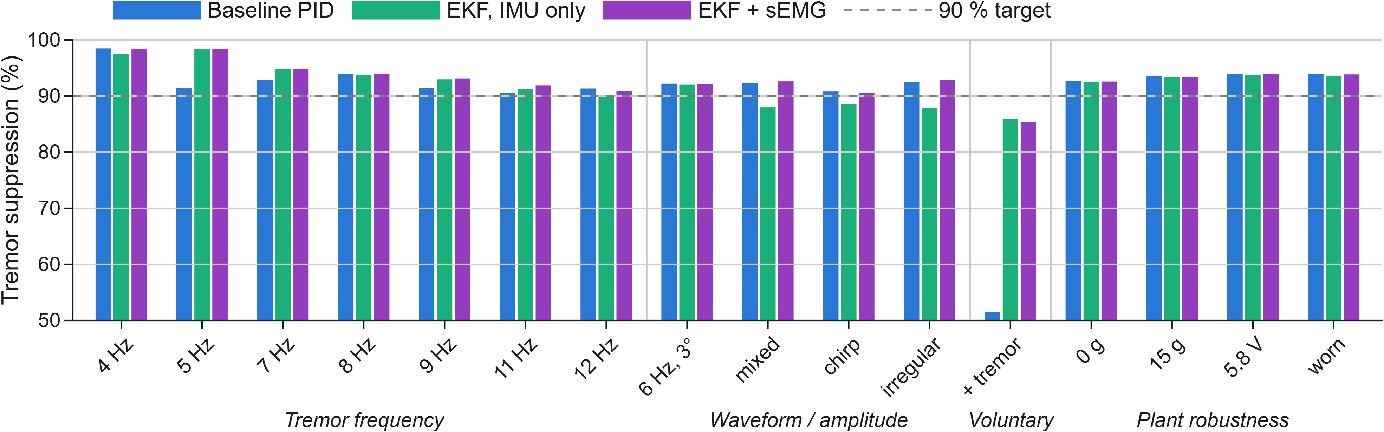
Fig. 3. Tremor suppression across the sixteen feasible scenarios, grouped by frequency, waveform, voluntary motion, and robustness. Dashed line: 90 % target.

E. Attribution: the Sensor, not the Mechanism
sEMG enters the estimator as a per-axis, per-sample scaling of the process noise on the voluntary-motion state — a confidence signal deciding how freely the estimator may attribute motion to intent. The obvious objection is that the benefit comes from that scaling and not from the muscle signal at all. The ablation variant in Table IV answers it: identical scaling, confidence held constant, no muscle signal present.
Measure | No sEMG | sEMG + IMU | Sensor gain
Feasible-case mean (%) | 85.18 | 93.04 | +7.86 pts
Movement + tremor (%) | −41.41 | 85.31 | +126.7 pts
Voluntary-only error (°) | 3.0418 | 0.2070 | 14.7× lower

TABLE V. Ablation — What the Sensor Contributes
The ablation behaves as predicted: holding confidence at a constant favourable value improves multi-frequency suppression and destroys everything involving deliberate movement. Any gain the delivered controller shows over both the IMU-only estimator and this ablation is therefore attributable to the sEMG stream and to nothing else. Inspecting the estimator confirms the mechanism directly — tremor mis-attributed to the voluntary state falls by 2.6× to 3.1× on the multi-frequency scenarios (0.171°→0.066°, 0.170°→0.055°, 0.038°→0.014°) with no loss of movement tracking.
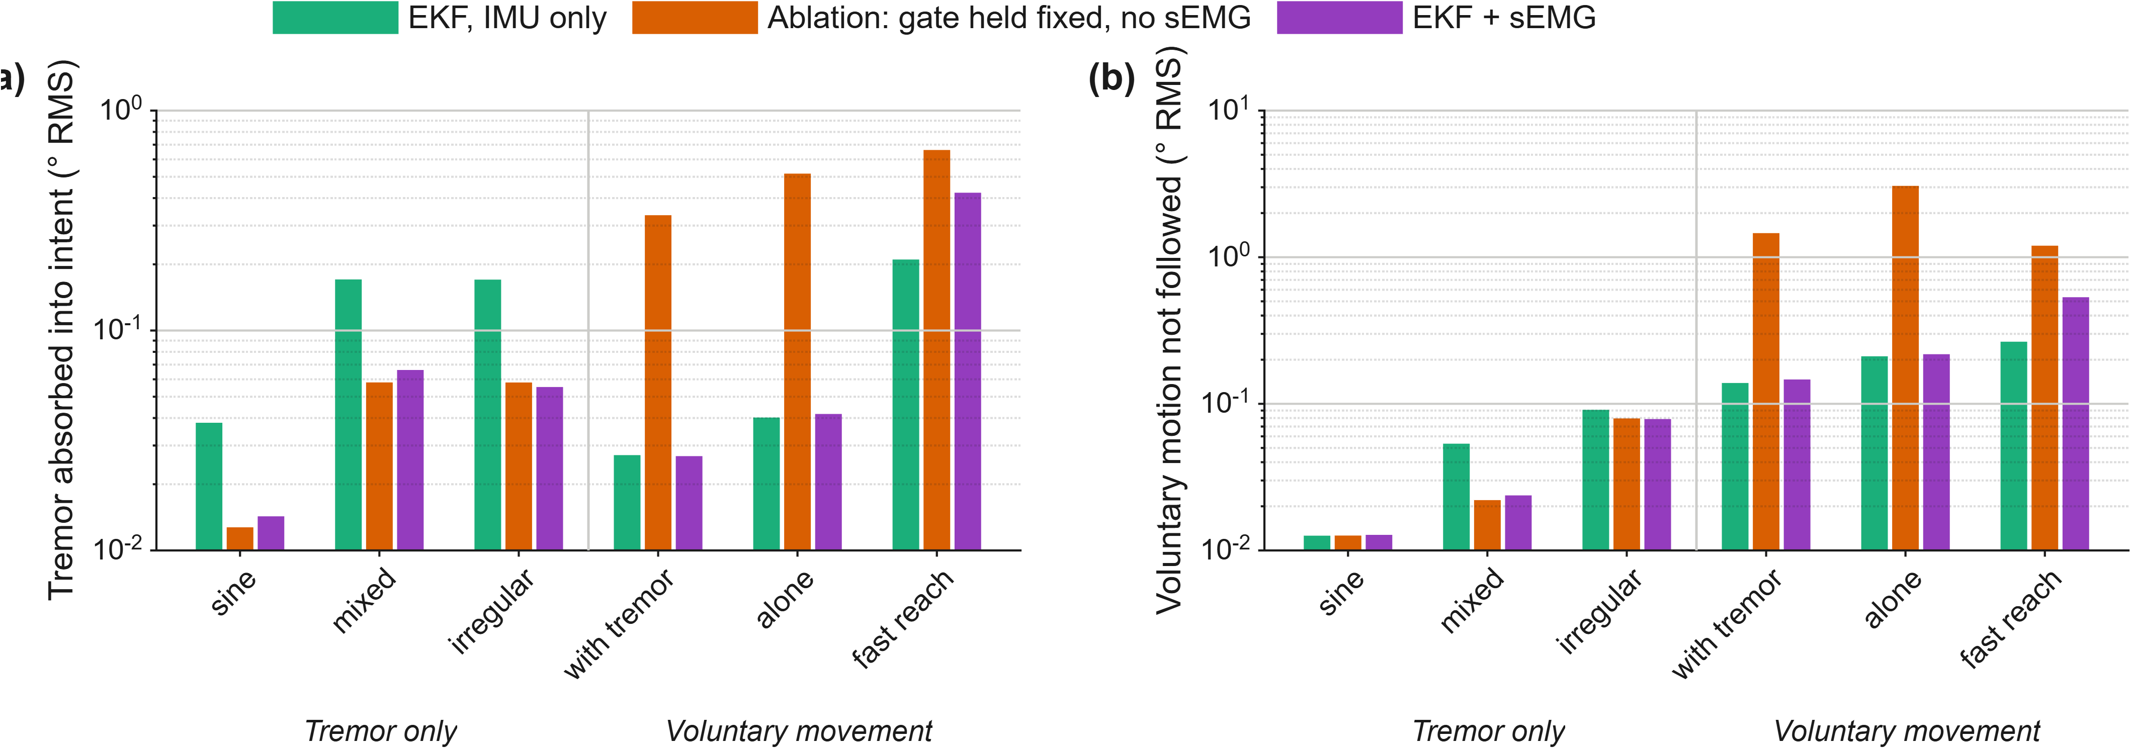
Fig. 4. The sEMG ablation. (a) Tremor mis-attributed to voluntary motion. (b) Voluntary motion missed. The ablation trades (a) for (b) with no muscle signal present — the trade sEMG exists to break. Log ordinates; lower is better.

F. Limitations Identified by Testing
Three targeted tests each found a failure mode. Fast voluntary movement: a 0.8 s reach added to tremor shows the gate at 407 ms against a 350 ms target, costing 2.4× the tracking error of the IMU-only estimator (0.697° vs. 0.289°) for only ≈0.6 points of suppression — a scenario absent from the Table IV benchmark. Rate-of-change detector: an earlier proposal to swap the amplitude detector for a rate-of-change one was tested and retracted after measurement showed it separates the two classes backwards (0.13:1–0.69:1 against a 4:1 requirement). Real forearm sEMG: on two GRABMyo [13] participants, wrist flexion separates as designed (10.1:1, 5.1:1) but extension does not, giving a pooled worst case of 0.1:1–0.8:1 against the 6.3:1 synthetic figure and the 4:1 requirement, from a resting DC offset and genuine co-activation absent from the synthetic model.

G. Feasibility Study: Recorded Human Tremor
Sections V-D and V-E used only synthetic tremor (sines and chirps, crest factor 1.414). This study replaces the tremor input with 60 recordings from 14 Parkinson's patients in the public PhysioNet tremordb database [14], [15] — index-fingertip velocity at 100 Hz, checksum-verified, band-pass filtered, integrated to displacement, and RMS-matched to the equivalent synthetic sine so tremor energy is comparable. The sEMG stream remains synthetic throughout, since no public dataset pairs muscle activity with measured tremor. The recordings are markedly less regular than the synthetic input (median crest factor 2.77, range 1.74–6.26) and span a broader dominant-frequency range (median 4.48 Hz, 2.41–8.41 Hz). Results are reported over the 46 records inside the 4–20 Hz design envelope; the remaining 14 are low-amplitude records whose dominant peak falls below the design floor.
Variant | Mean (%) | Worst (%) | ≥90 % | RMS (°)
Fixed notch chain | 81.62 | 52.65 | 8/46 | 0.2080
EKF, IMU only | 73.16 | 29.58 | 8/46 | 0.3073
EKF + sEMG | 86.81 | 62.62 | 21/46 | 0.1464

TABLE VI. Suppression on Recorded Tremor, 46 In-Band Records
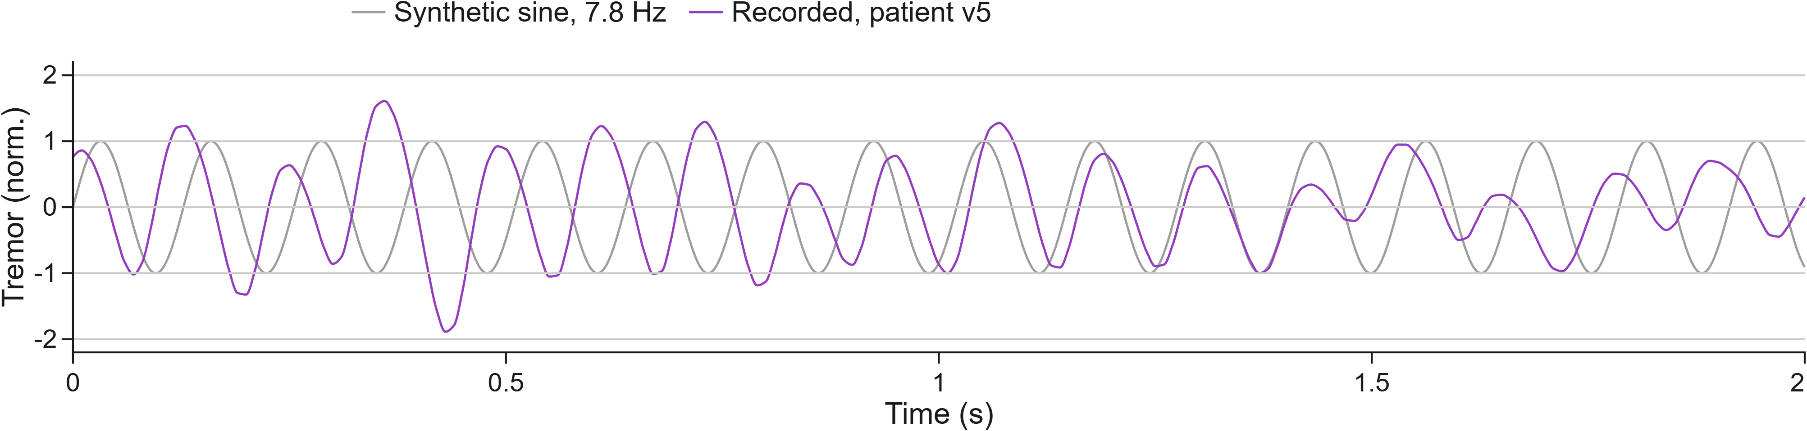
Fig. 5. Recorded human tremor: a conditioned tremordb recording against the RMS-matched synthetic sine at the same dominant frequency.
Two findings stand out. The synthetic benchmark is optimistic: suppression falls from 93.04 % (Table IV) to 86.81 % on recorded tremor, meeting the 90 % target on fewer than half the records. And the shortfall is the estimator's, not the plant's — against a paired synthetic control at the same frequency, the IMU-only estimator loses 23.79 points on recorded tremor, because a single-frequency tremor model mis-fits a wandering real frequency by construction, while the fixed-notch baseline loses essentially none only because its fixed notches never track the input at all. sEMG narrows that loss to 9.54 points, so the sensor's margin over IMU-only grows roughly fifteenfold on recorded tremor relative to synthetic (+0.92 to +13.65 points). This is a real-signal robustness test of the algorithm, not a clinical result: the muscle signal stays synthetic, the recordings are Parkinsonian fingertip rest tremor rather than wrist tremor during feeding, and a single axis drives both joints.

H. Threats to Validity and Reproduction
In order of impact on these conclusions: no hardware measurement was taken, so every actuator and flexure parameter is unverified; the sEMG signal is synthetic throughout, so every sEMG figure is an upper bound; the plant omits hysteresis, creep and backlash; the 40 ms electromechanical delay the gate's timing rests on is a literature value [12], not measured; and a sustained isometric hold would read as deliberate movement, untested but the safer failure direction. A short synchronised recording of forearm sEMG and limb motion (rest, tremor, reaching) would close most of these at once, and is the natural next step before any hardware or clinical claim.

